# Weller GSHP

# Data Measurement and Recording Standards

Last Update: 5/9/2011

Last Update By: Robbin

# In-ground Temperature Sensors

Main Question Intended: How does the ground temperature change within the heat pump ground loop?

Sensor: Maxim DS 18B20+PAR

Location: 3 strings of nine sensors in the pit to 22 feet depth, one string of 22 feet depth to side of pit, Depths: 1, 4,6,8,10,12,14, 18, 22 ft from grade

Measurement Range: -55°C to 100°C

Output Units: temp in ° C

Scan Interval: Hourly

Folder Location: \\Yaranga\cchrc\Building Science Research\Projects\Weller Heat Pump\Ground Program and Sensors

**In-building sensors**

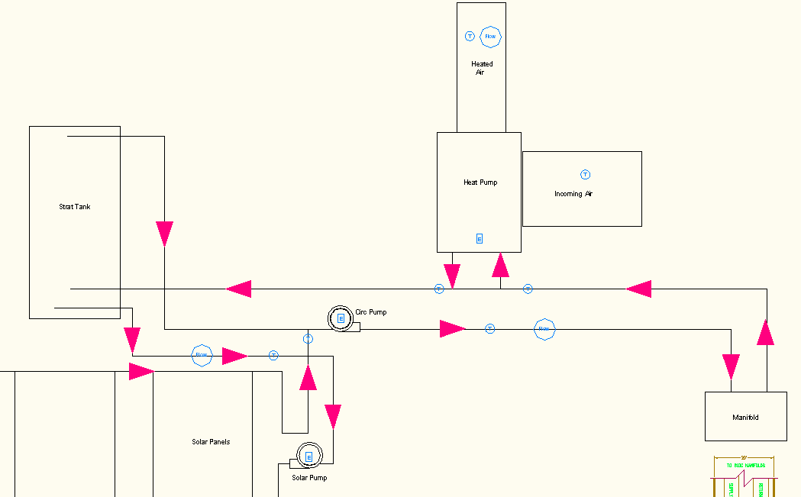

**Duct Flow Meter**

* Sensors
  + Flowmeter – Air_Flow in CFM
  + Before heat pump – thermistor in duct before heat pump – Duct_Temp in °C
  + After heat pump – Air_exit_temp in °F

Main Question Intended: How much heat energy does the heat pump supply?

Sensor – Ebtron model STx104-PB

Location: in the duct leaving the heat pump

Measurement Range: -20 to 160 °F

Output Units: amps

Algorithm:

airflow=2.243*(x*8.474-4)/16*5000

airtemp=(x*8.474-4)/16*(160+20)-20

thermistor

R = 10*10**3

X = 2*10**9

a=0.0011253

b=.000234

c=.0000000856

y=R*X/(R+X)

y=y*((5/x)-1)

thermistor temp=(1/(a+b*d+c*d**3))-273.15

Scan Interval:

**Heat Pump Loop BTU meter**

* Temperature sensors
  + Before ground loop/after buffer tank – thermistor - GL_return_temp x2 °C
  + Before heat pump – GL_supply_temp °F
  + After heat pump – HP_exit_temp °F
* Flow Rate – GL flow rate - GPM
* Energy Output – GL HP BTU rate BTU/hr

Main Question Intended: How much heat energy does the ground loop supply?

Sensor : Onicon F1100

Location: after pump 1 before ground loop

Measurement Range: 20 °F to 205 °F

Output Units: amps

Algorithms:

Temp=(x*31.78)-5

Flow=(x*15.89)-7.5

Thermistor

R = 10*10**3

X = 2*10**9

a=0.0011253

b=.000234

c=.0000000856

y=R*X/(R+X)

y=y*((5/x)-1)

thermistor temp=(1/(a+b*d+c*d**3))-273.15

Scan Interval:

**Solar Loop BTU meter**

* Temperature sensors
  + Before solar panel – SL_supply_temp °F
  + After solar panel – SL_exit_temp °F
* Flow Rate – SL flow rate – GPM
* Energy Output – SL BTU rate BTU/hr

Main Question Intended: How much energy does the solar loop provide?

Sensor : Onicon F1100

Location: after pump 2 before solar panels

Measurement Range: 20 °F to 205 °F

Output Units: amps

Algorithm:

returnTemp=(x*90.04)-12.5

supply Temp=(x*37.07)+12.5

Flow=(x*15.89)-7.5

Scan Interval:

**Pump 1 Electrical Meter**

Main Question Intended: How much energy does the pump use?

Sensor CR8410-1000G x3 (3 phase power)

Location: on electrical supply

Measurement Range: 7 amp max

Output Units: amps

Algorithm: amp=((x/20)/5.9)*1007

Scan Interval:

**Pump 2 Electrical Meter**

Main Question Intended: How much energy does the pump use?

Sensor CR8401-1000-G

Location: on electrical supply

Measurement Range: max 4 amp

Output Units: amps

Algorithm: amp=((x/20)/5.9)*1005

Scan Interval:

**Heat Pump Electrical Meter**

Main Question Intended: How much energy does the pump use?

Sensor CR 8420-1000 x3 (3-phase power)

Location: on electrical supply

Measurement Range: max 50 amps

Output Units: amps

Algorithm: amp=((x/20)/5.9)*1018

Scan Interval: